**Assignment – 2**

**Module: 3.1 (C Language Fundamental)**

1. **Display This Information Using Printf**
   1. **Your Name**
   2. **Your Birth Date**
   3. **Your Age**
   4. **Your Address**

**🡪**

**Input:**

#include<stdio.h>

#include<conio.h>

int main () {

char name [20], birthday[10], age[15], address[50];

printf("Please enter your name: ");

scanf("%s",& name);

printf("\n");

printf("Please enter your birthday: ");

scanf("%s",& birthday);

printf("\n");

printf("Please enter your age: ");

scanf("%s",& age);

printf("\n");

printf("Please enter your address: ");

scanf("%s",& address);

printf("\n");

printf("\n");

printf("your name is : %s", name);

printf("\n");

printf("Your birthday is : %s", birthday);

printf("\n");

printf("Your age is : %s", age);

printf("\n");

printf("Your address is : %s", address);

printf("\n");

getch();

}

**Output:**

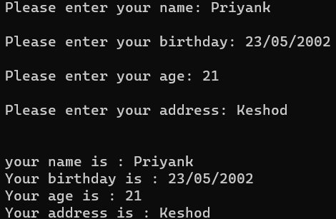

1. **Write A Program To Make Simple Calculator (To Make Addition, Subtraction, Multiplication, Division And Modulo)**

**🡪**

**Input:**

#include <stdio.h>

main() {

int num1, num2, x;

printf("Enter one numbers: ");

scanf("%d", & num1);

printf("\n");

printf("Enter second numbers: ");

scanf("%d", & num2);

printf("\n");

x = num1 + num2;

printf("Addition of the two numbers is: %d", x);

printf("\n");

printf("\n");

x = num1 - num2;

printf("Subtraction of the two numbers is: %d", x);

printf("\n");

printf("\n");

x = num1 * num2;

printf("Multiplication of the two numbers is: %d", x);

printf("\n");

printf("\n");

x = num1 / num2;

printf("Division of the two numbers is: %d", x);

printf("\n");

printf("\n");

return 0;

}

**Output:**

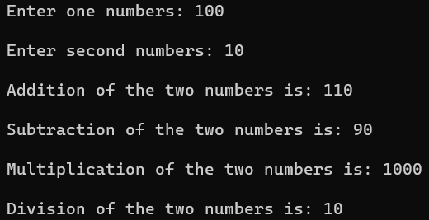

1. **WAP To Find Area Of Circle, Rectangle And Triangle**

**🡪**

**Input:.**

#include <stdio.h>

void main() {

float r, l, w, b, h;

// Circle

printf("Enter the radius of the circle: ");

scanf("%f", &r);

printf("The area of the circle is: %.2f\n", 3.14 * r * r);

printf("\n");

// Rectangle

printf("Enter the length of the rectangle: ");

scanf("%f", &l);

printf("Enter the width of the rectangle: ");

scanf("%f", &w);

printf("The area of the rectangle is: %.2f\n", l * w);

printf("\n");

// Triangle

printf("Enter the base of the triangle: ");

scanf("%f", &b);

printf("Enter the height of the triangle: ");

scanf("%f", &h);

printf("The area of the triangle is: %.2f\n", 0.5 * b * h);

}

**Output:**

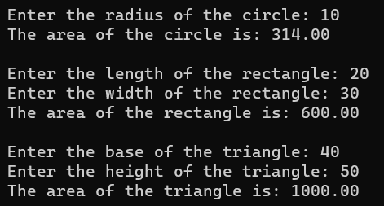

1. WAP To Find Simple Interes

🡪

**Input:**

#include <stdio.h>

int main()

{

float principle, time, rate, SI;

/* Input principle, rate and time */

printf("Enter principle (amount): ");

scanf("%f", &principle);

printf("\n");

printf("Enter time: ");

scanf("%f", &time);

printf("\n");

printf("Enter rate: ");

scanf("%f", &rate);

printf("\n");

/* Calculate simple interest */

SI = (principle * time * rate) / 100;

/* Print the resultant value of SI */

printf("Simple Interest = %f", SI);

return 0;

}

**Output:**

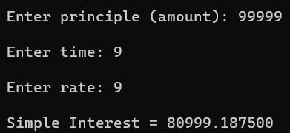

1. WAP To Check If The Given Year Is A Leap Year Or Not.

**🡪**

**Input:**

#include <stdio.h>

int main() {

int year;

printf("Enter a year: ");

scanf("%d", &year);

printf("\n");

if (year % 400 == 0) {

printf("%d is a leap year.", year);

}

else if (year % 100 == 0) {

printf("%d is not a leap year.", year);

}

else if (year % 4 == 0) {

printf("%d is a leap year.", year);

}

else {

printf("%d is not a leap year.", year);

}

return 0;

}

**Output:**

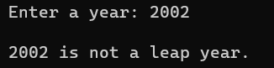 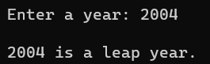

1. WAP To Convert Years Into Days And Days Into Years

🡪

**Input:**

#include <stdio.h>

int main() {

int days, years;

printf("Enter number of days: ");

scanf("%d", &days);

years = days / 365;

days = days % 365;

printf("Years: %d\n", years);

printf("Days: %d\n", days);

return 0;

}

**Output:**

